FACULTY EVALUATION
Programme Name: SEP Scale Alumni Masterclass Module 1 Tanzania (11th May 2026 - 15th May 2026)
Session: Customers and competitor evaluation || Market potential evaluation || Customers, competitors and market planning
Faculty Name: Dr. Adriana Lyamba
No. of Respondents: 18
No. of Participants: 18
Evaluation Parameter | (%) Individual Score | (%) Programme Average
Punctuality (Commencement and Completion of Sessions) | 98 | 92
How well do you understand the core concepts presented? | 86 | 88
Rate your confidence in applying the new skills learnt | 87 | 85
Degree of Faculty preparedness for the sessions | 92 | 90
Content and methodology of the program | 90 | 90
Quality of class and group discussions | 86 | 89
The information presented in the course is relevant to my work (ministry) | 92 | 92
Average scores | 90 | 89

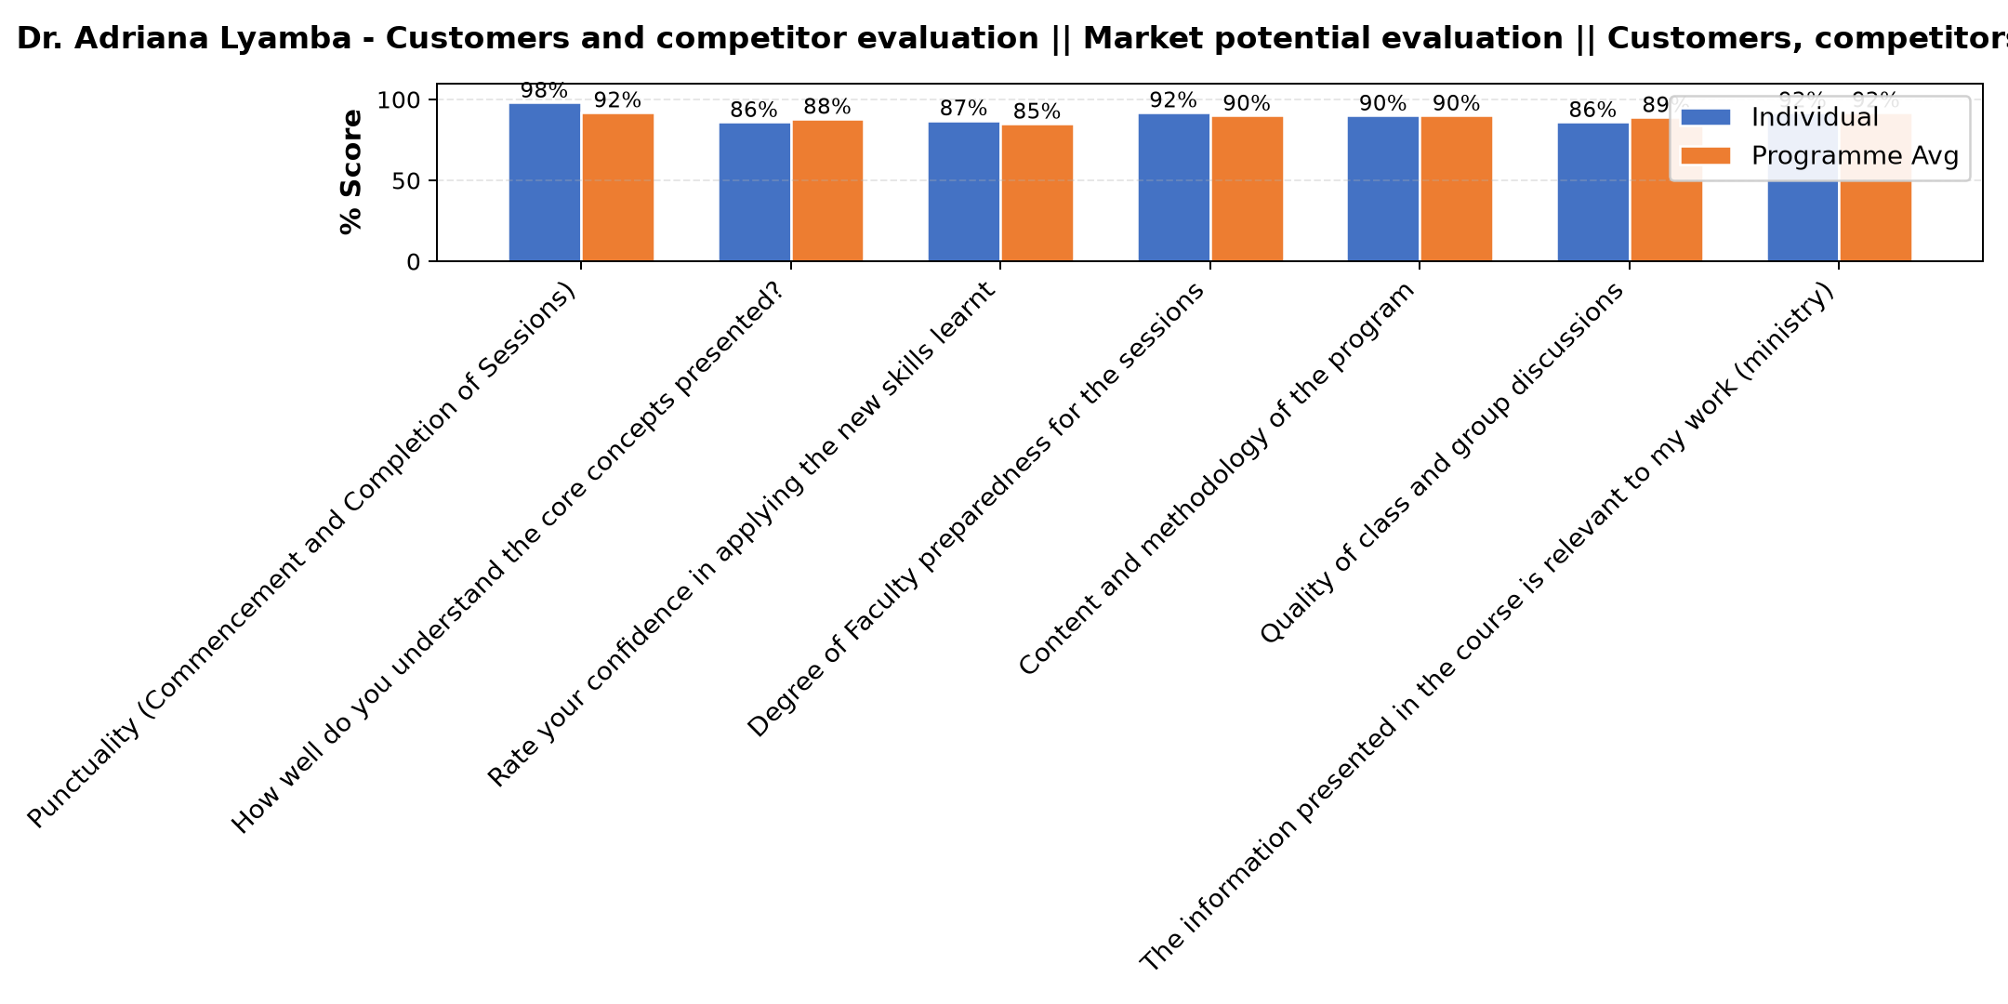

Comments & Feedback
- • The lesson was so good
- • The barrier would be lack of enough skills for segmentation and capital. Customer segmentation needs research and data collection.
- • Some barriers that might prevent me from applying what I learned about customer segment and competitor evaluation include limited time to conduct proper analysis, lack of enough data about customers and competitors, and limited resources to implement marketing strategies. Another challenge may be resistance to change within the organization and difficulty in consistently updating market information.
- • Failures to categorize customers in segments
- • Network problem
- • Workload
- • How to manage custommers
- • Sometimes a network
- • Fear of taking risk
- • To look the customer needs according to the environment
- • To change the mind set of those who think they know everything.
- • Uwezekano wa kukosa ushirikiano wa wale nitakoenda kuwashiirikisha
- • Good customer segimentation might be challenging in school because parents' preferences change with examination results. This may make it difficult to maintain accurate data.
SUBMITTED THROUGH:
SBS Evaluation Automation System

